[Insert Course Name]
Insert Organization Name
Insert Date

CTIP Program Management Office

Table of Contents

Table of Contents 1
[Title of Lesson]- Administrative Page 2
Lesson Overview 2
Lesson Organization 2
Target Audience 2
Terminal Learning Objective (TLO) 2
Enabling Learning Objective (ELO) 2
Start/end date(s) and time(s): 2
Assessment Strategies: 2
[Title of Lesson]- Instructor Notes 3

[Title of Lesson]- Administrative Page
This section provides a generic template for instructor-led training facilitators. Components may choose to use to track administrative information related to training and notes for the training facilitation. Duplicate this page for each lesson.

Lesson Overview
[Insert target audience]

Lesson Organization
Section # | Section Title and Description
1 | Title
2 | Title
3 | Title
4 | Title
5 | Title

Target Audience
[Insert target audience description]

Terminal Learning Objective (TLO)
[Insert terminal objective]

Enabling Learning Objective (ELO)
[Insert enabling learning objective]

Start/end date(s) and time(s):
[Insert start/end date(s) and time(s).]

Assessment Strategies:

[Insert assessment strategies]
Instructor Notes
[Insert instructor notes]

[Title of Lesson]- Instructor Notes
[Insert Title of Slide and Slide Number]
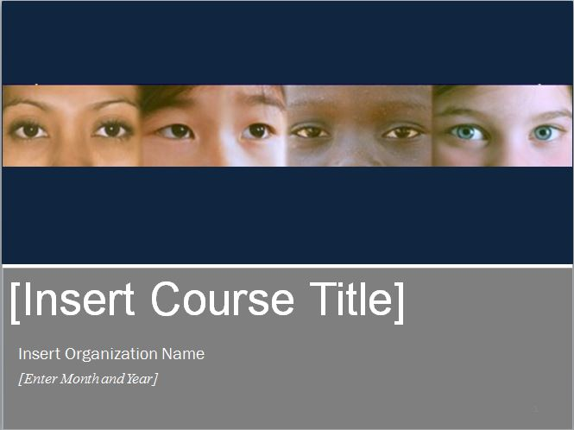

Instructor Notes:
- [Insert notes related to the slide.]
- [Insert notes related to the slide.]

